**1.Introduction**

* Design a social media post by using Canva app
* That was very easy to use
* Anyone can easily use Canva app

**1.1Purpose**

* My project is creating a social media post
* I create a social media post by using Canva

2.Problems Definitions & Design thinking

**2.1 Empathy Map**

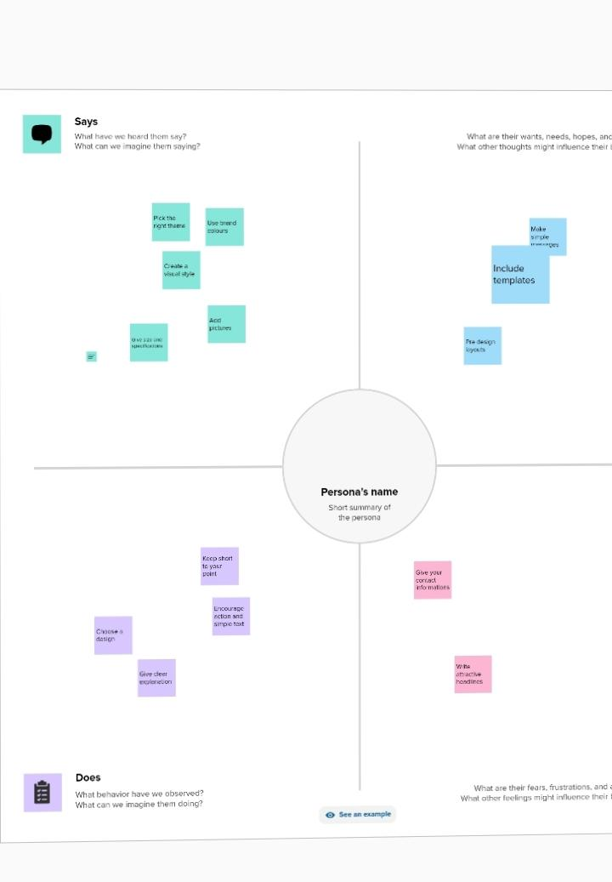

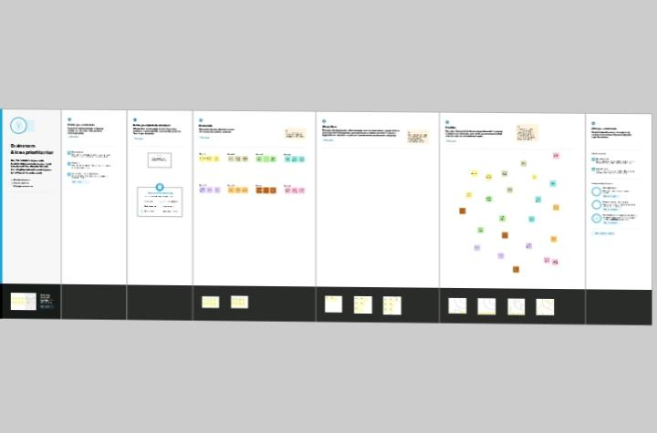

**3.Result**



**4.ADVANTAGES**

* Very easy to use Canva
* Freshers also easily learn and design anything by Canva.
* Canva has multiple templates
* Canva app was very useful to everyone

**5.Conclusion**

I easily finish my project social media post by Canva app. Canva is the most useful app for freshers Because this app has many templates and images,sticters,font ,etc and very easy to use.